**STEAM**

**SOLUTION PROPOSAL**



**CONTENTS**

[1](https://docs.google.com/document/d/1faVgm2jjX2cc5dvUU3-q8G-L211lk8e_JIC86CZVG08/edit#heading=h.m4d9912vy4fy).Problem Statement

2.Root Cause Analysis

3.Recommended Solution

4.Challenges

1. **Problem Statement**

Due to rising number of games on different platform the number of Steam concurrent users has significantly decreased.The business needs a solution to regain back their users.

1. **Root Cause Analysis**

The root cause analysis for the decrease in concurrent Steam users have three possible key areas to consider could be:

* Software
* Subscription service
* Users

In terms of **Software:**

1. **User End Experience**

* Layout and design for both PC/Android are not intuitive.
* Hard to filter content to own preferences
* A messy design which is not aligned properly example feedback box

1. **Bugs and glitches**

* Chat message often fail to send
* Email verification issue
* Sign in/Sign up issue

1. **Less features**

* Only can text or buy games through the mobile version of Steam - unable to play online games.
* No additional features

Example to create group chat

* Unable to review games through app

1. **Less security**

* Has a weak spot in allowing third party access account when using Steam Guard Mobile Authenticator
* Doesn’t protect the main store info

In terms of **Subscription Service**:

* Not enough payment options are offered to the users.

When considering **Users** the potential causes may be:

* Don’t use software continuously
* Delays when contacting support

For increase the productivity, i have use fish-bone diagram approach for my root cause analysis:

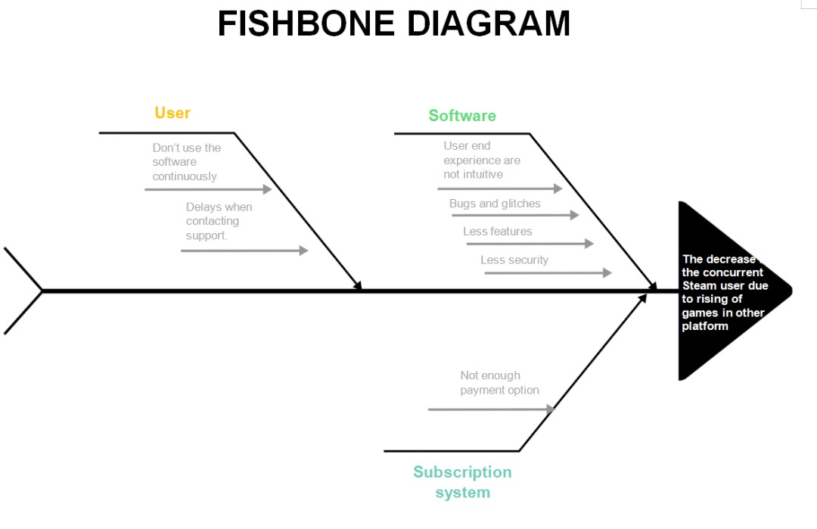

1. **Proposed Solution**

The proposed solution for the three possible key areas are:

**Software:**

* To provide a better user interface for the end users by creating a better UI/UX design for the website layout on PC and improve the responsiveness in mobile version.
* To fix all the existing bugs and glitches for better user performance and also consistently provide better maintenance after the product is released to the market.
* To improve existing features and add few more features in the existing platform. For example the current mobile version supports only for chat and purchasing games but this can be improved by adding features to play the games in the mobile version.
* Provide better security when using Steam Guard Mobile Authenticator to avoid unwanted third party access. Enhance the privacy or protection of the few important modules in the games such as store or inventory info for game improvement.
* Valve should improve the quality of the in terms of testing by providing a better protocol for their system. They need to incorporate different types of testing methodology such as system testing and acceptance testing.
* Implementation of data analytic **can** help Valve better understand their customers, evaluate their ad campaigns, personalize content, create content strategies and develop products.

**Subscription system**

* Improve the existing payment method by adding more options such as by adding online payment,third-parties e-wallet or even creating a Steam wallet where users can top-up for further usage.

**Users**

* Though Steam has more than 10,000 of online games in it’s platform their target should be dependent on their audience type. More games exclusive for female gamers should be introduced to gain more popularity in their community.This will add more value and increase the percentage of with the existing number of female gamers.In this way,the software will be continuously in use within male and female gamers.
* The support team should be continuously engaged in solving users' problems related to the software. A stable support team should be set up.

1. **Challenges**

The challenges for Valve in implementing the solution are:

* Understanding the customer requirement/needs and implementing into a business solution.
* Needs more technical and human resources. Valve needs to find and invest in more experienced sources to improve the quality of the platform in terms of improving the interface and adding new features.
* Improving the software training tools such as quality assurance process and establishing a better project infrastructure for the development of the project.
* Adapting the latest market trends by catering to latest technology needs such as mobile-only or desktop first. This also includes managing the product design to maximize the quality of the system by offering a consistent experience across devices and operating devices.
* Improving the security infrastructure of the software.